

**TEAM J AI FOR CO2 REDUCTION PROBLEM DOCUMENTATION**

**1.0 Problem Statement/Definition Who (whom) has identified the problem?**

They say too much of a good thing is a bad thing, this applies to atmospheric CO2: In higher concentrations, it is a damaging pollutant. Hence, industries that contribute to higher CO2 emission due to their production activities need to be able to use unsupervised machine learning techniques to discover new materials with low CO2 emission rate in their production processes.

**1.1 Prevalence of the problem**

Carbon dioxide is an important component of the atmosphere because it plays multiple roles in keeping Earth’s climate stable. CO2 and other greenhouse gases are an essential part of the recipe because they trap heat in the atmosphere. With no CO2, Planet Earth would be in a perpetual ice age; However too much of it overheats the planet. Talking about the fertilization myth surrounding CO2, it’s only the right quantity of CO2 that can impact the fertilization of plants, an extra CO2 causes an imbalance within the crop’s chemical makeup causing a growth disruption in the plants.

Carbon dioxide emissions are those stemming from the burning of fossil fuels and the manufacture of cement. CO2 emissions increased by 0.70% over the previous year, representing an increase by 578,039 tons over 2015, when CO2 emissions were 82056,175 tons.

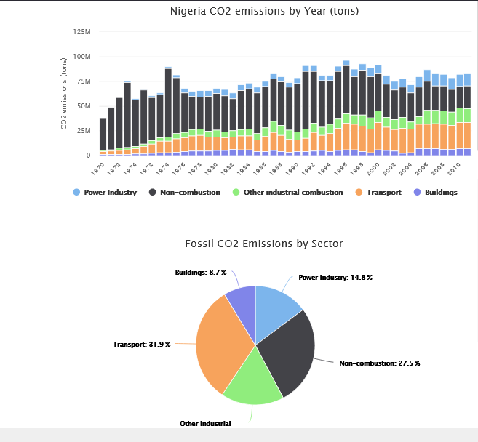

* 1. **Cause of the problem**

There are both natural and human sources of carbon dioxide emissions. Natural sources include decomposition, ocean release and respiration. Human sources come from activities like cement production, deforestation as well as burning of fossil fuels like coal, oil and natural gas.



Fig.1 Emissions per day through a year for different countries.

 Fig.2 Emissions per day from different sources.

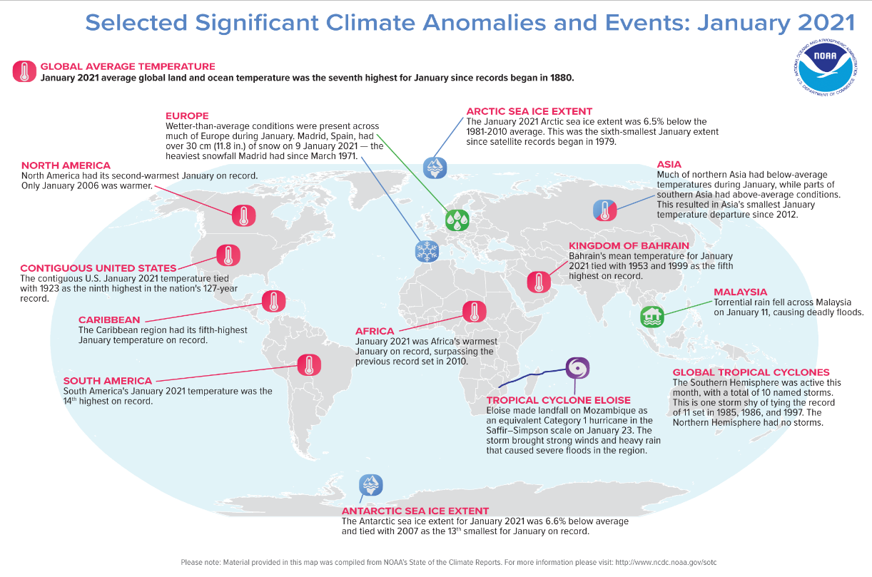

* 1. **Who (whom) has identified the problem?**
* Folasewa Maryam ABDULSALAM: A 400L undergraduate of Department of Computer Science and Engineering, Obafemi Awolowo University, Ile-Ife. She has worked as a Data Science intern at places like Korwave, USA (a BioMed company for using AI to develop wearable seizure monitors), Computing Intelligent System Research Lab OAU and she is also aspiring to be an Artificial Intelligence Research Scientist to utilize the power of AI in solving some health problems in the health sector.

Email: [abdulsalammaryam381@gmail.com](mailto:abdulsalammaryam381@gmail.com)

LinkedIn: <https://www.linkedin.com/in/folasewa-abdulsalam-81ba8616b>

* Muhammad Ibrahim MURTALA: A 300L undergraduate of Department of Chemical Engineering, Abubakar Tafawa Balewa University, Bauchi. He is passionate in utilizing the incredible power of AI to blend Chemical Engineering with AI.

Email: [murtalaib31@gmail.com](mailto:murtalaib31@gmail.com)

LinkedIn: [www.linkedin.com/in/ibrahim-murtala-muhammad-8608711b](http://www.linkedin.com/in/ibrahim-murtala-muhammad-8608711b)

* 1. **Affected group/demography**

People living in small islands developing states and other coastal regions, mountainous and polar are particularly vulnerable. Children in particular, children living in poor countries are among the most vulnerable to the resulting health risks and will be exposed longer to the health consequences. The health effects are also severe for the elderly people and people with infirmities or pre-existing medical conditions.

* 1. **Adverse effect of the problem**

The amount of carbon dioxide emissions trapped in our atmosphere causes global warming, which causes climate change, symptoms of which include:

1. Melting of the polar and ice caps
2. The rising sea levels
3. The disturbance of animal’s natural habitats
4. Extreme weather events
5. Wildfires
6. Reduction of yields for crops
7. Broaden the ranges of disease-carrying creatures like mosquitoes and ticks
   1. **Why should the problem be solved?**

The problem of CO2 emission should be solved because of the following reasons:

* Improve air quality
* Increase in economic growth
* Slowed climate change
* Cost savings
* Improve external relations
  1. **List the major stakeholders leading advocacy or actively championing for this problem**
* UN environment programme

unepinfo@upnep.org

United Nations Environment Programme

United Nations Avenue, Gigiri

P.O Box 30552, 00100

Nairobi

Kenya

[Tel: (254-20)](Tel:(254-20)) 7621234

* U.S Environmental Protection Agency EPA

Environmental Protection Agency

1200 Pennsylvania Avenue, N.W.

Washington, DC 20460

* Arab Forum For Environment and Development

Eshmoun bldg,

Ruede Damas,

Downtown, Beirut.

<Tel:(961)> 1321800

Fax:(961) 1321900

[info@afedoline.org](mailto:info@afedoline.org)

* 1. **List the major stakeholders leading advocacy or actively building solutions for the problem**
* West African Development Bank

Avenue de la Liberation

<Tel:(228)> 22215906

[boadsiege@boad.org](mailto:boadsiege@boad.org)

* UN environment programme

unepinfo@upnep.org

United Nations Environment Programme

United Nations Avenue, Gigiri

P.O Box 30552, 00100

Nairobi

Kenya

* Climate Justice Alliance

[info@climatejusticealliance.org](mailto:info@climatejusticealliance.org)

* Data Science Nigeria

[www.datasciencenigeria.org](http://www.datasciencenigeria.org)

[info@datasciencenigeria.org](mailto:info@datasciencenigeria.org)

**2.0 Existing Solutions**

Due to the highly prevalent nature of CO2 emissions that leads to climate change and all of its effects, there are couple of solutions that have been created to actively combat this menace. They include Climeworks, Fuelgems, Terramera, Carboncure.

* 1. **Climeworks:**

**2.1.1 What is origin and status of the solution?**

Climeworks is a Swiss company specializing in carbon dioxide air capture technology. The company filters the CO2 directly from ambient air through an adsorption-desorption process. The company was founded in November 2009 by Christoph Gebald and Jan Wurzbacher as a spin-off from ETY Zurich. Climeworks technology is available through monthly subscription models: Explorer at $8/month, Discover at $24/month, and Expedition at $55/month. www.climeworks.com

* + 1. **Features of the Solutions**

It uses a filter that is designed to capture atmospheric carbon, drawing in air and binding the CO2. It then releases concentrated gas through a heated filter. The gases can be uses in industrial applications such as Enhanced Oil Recovery(EOR) among others. The CO2 collectors are stackable to build machines of any size and power is solely by renewable energy or energy from waste. Grey emissions are below 10%

* + 1. **Shortcomings of the solutions**

Even though Climeworks plants are currently 90% efficient, emitting 10kg of CO2 for every 100kg removed from the atmosphere, the major drawback of direct air capture is that more energy is required to separate the CO2 from air than from a power plant because it is more dilute in CO2 (390ppm in air and about 12 mole percent in coal power plant flue gas).

* 1. **FuelGems**

**2.2.1 What is origin and status of the solution?**

Fuelgems was founded in 2015 by Kirill Gichunts. The company produces a revolutionary, powerful, multi-action fuel additive that reduces harmful greenhouse emissions and saves fuel. The company is still in a pilot stage but it is striving to become the most successful fuel additive worldwide. [www.fuelgems.com](http://www.fuelgems.com)

**2.2.2 Features of the solution:**

The company produces a fuel additive that uses tiny micro-doses of carbon-based nanoparticles to reduce the damaging effects on the environment. It boosts the cleanliness and performance of gasoline, diesel and bio-fuel. The additive reduces greenhouse gas and dangerous emissions by 50% and improves lubricity to extend engine and fuel pump life. There is also a 9% fuel savings and reduction in particulate matter.

**2.2.3 Shortcoming of the solution:**

The produce is still in pilot stage and not accessible to the public and also the product reduces emissions by 50%, more than that will be needed to reach net zero emission by 2050.

* 1. **Terramera**

**2.3.1 What is origin and status of the solution?**

Terramera was founded in 2010 by Karn Manhas who is an entrepreneur with headquarters in Vancouver, British Columbia, Canada with integrated operations in Canada, the US and India. The company uses science and AI to create game-changing technologies to solve problems relating to food waste which accounts for about 8% of all global CO2 emission. Its products are available for sale on their website. [www.terramera.com](http://www.terramera.com)

**2.3.2 Features of the solution:**

The company’s regenerative agriculture pull carbon from air and sequester it in the soil. This improves plant and soil health, reduces pesticide and fertilizer use, and dramatically reduces atmospheric carbondioxide.

* 1. **CarbonCure**

**2.4.1 What is origin and status of the solution?**

CarbonCure was founded in 2007 by Rob Niven who had recently graduated with a Masters in Environmental Engineering from McGill University, where he studied the benefits of introducing CO2 to fresh concrete. The company has their headquarters in Halifax, Nova Scotia. Their product in on their website.

[www.carboncure.com](http://www.carboncure.com)

**2.4.2 Feature of the solution:**

CarbonCure helps the concrete industry reduce its carbon footprint and improve operation using technology that recycled CO2 into fresh concrete. This reduces carbon footprint without compromising performance. When the CO2 is injected, it goes through a mineralization process and becomes permanently embedded in the concrete. It can be used with ready-mix, precast, or masonry concrete.

* + 1. **Shortcomings of the solution:**

The equipment requires an agent to be onsite and if a failure might happen without a CarbonCure agent onsite, the carbon emission will be on the positive side and the time taken for the arrival of the agent and maintenance will negatively affect the timeline for the project.

**3.0 What needs to happen to address the problem?**

1. **DESIGN AN INFERENCE ENGINE (considered within scope)**

This is the brain of the decision support system. It provides reasoning about the information in the knowledge base. It helps in deducting the problem to find the solution. It also helps in formulating conclusions.

1. **CREATE A KNOWLEDGE BASE (considered within scope)**

This is a repository of facts where all the knowledge about the problem domain is being stored. It’s like a large container of knowledge which is obtained from different experts of that specific field. The field we are concerned about here is material science. The success of this prediction system is largely dependent on how accurate and precise the knowledge is.

1. **PROTOTYPE A USER INTERFACE (considered within scope)**

This is the most crucial part of this decision support system. This component takes in the user’s query in a readable form and passes it to the inference engine. After which it displays the results to the user. The user in this case is the scientist/builder. In short, this interface helps the user communicate with the intelligent prediction system.

1. **GOVERNMENT POLICIES (considered outside scope)**

Since this project requires a pull of funding, workforce and legal backing, the government should be able to back it up with policies that will attract investors to this project.

1. **AVAILABILITY OF EXPERTS (considered outside scope)**

As this project is knowledge driven, we cannot but talk about the experts who will be in charge of managing the system’s input and working operation.

**3.1 Key physical infrastructures that must be in place**

1. **Data Center**

This is a dedicated space within a building that houses critical applications and data. This is very critical in building a solution because our prediction system solely relies on data and it is very important to have a dedicated building where all these data are stored in which the prediction system could have access to.

1. **Hybrid Cloud Infrastructures**

This refers to a mixed computing, storage and services environment made up of on-premises infrastructure, private cloud services and a public cloud. This is needed to create a single, flexible cost-optimal IT infrastructure.

**3.2 Stakeholders involved in solving the problem**

1. Material Scientist
2. The Builders
3. Knowledge Engineers
4. Decision Support System Engineers
5. Regulatory Agencies
6. The media

**3.3 Why is AI and Data is presumed to be helpful addressing this problem?**

Obviously, since the goal is to discover more efficient, cost-effective and low carbon emission ways of making cement. The role of AI (Decision support system) here is to provide a friendly interface where the agents (in this case, the scientists and builders) can build scenarios, simulate and obtain reports and visualizations.

1. **Because of its predictive capabilities**: Clustering techniques to group the cement into low CO2 production techniques and high CO2 production techniques. It predicts the threshold that should not be exceeded when forming compounds with low CO2 emission capabilities. With its access to big data, unsupervised machine learning techniques would be used to form interesting new materials, here in this case, cement.
2. **Because of its optimization abilities**: Smart systems powered by optimized algorithms are known to be fast in processing, it will look through different combinations of compounds in split seconds. The time between discovering a material and integrating it into a product would be shortened leading to optimized cement production.
3. **Continuous learning and improvement**: The fact that as more data is being fed back to the algorithm, the more it grows smarter and smarter each time. The use of deep neural networks as the framework of the decision support system makes it learn each time it makes a new discovery of materials. The more the data, the smarter the algorithms are.
4. **Because of its opportunities for visualizations**: The use of graphics and images improve the perception for the data analysis helping a faster recognition of trends, corrective actions can also be done.
   1. **List impact of data and available data /datasets surrounding the problem and the condition for their access**

Available datasets are:

1. <https://data.world/toxman/udemy/workspace/file?filename=carbon-emissions-borough.xls>
2. <https://www.kaggle.com/debajyotipodder/co2-emission-by-vehicles>
3. <https://data.world/data-ny-gov/djfn-trk4>
   1. **Is such an approach feasible and sustainable?**

This approach is feasible because of availability of faster algorithms, a complete infrastructure and more open source data. Algorithms like the genetic algorithms which includes useful genetic optimization techniques, deep neural networks that would be used to model complex poorly understood problems. Its availability as an open source solution would prolong its sustainability as different scientists and developers would be interested in making meaningful contributions.

1. **Possible Artificial Intelligence Solutions**

A combination of unsupervised and deep neural network based system that uses clustering techniques to group cement production processes into one with low CO2 and high CO2 production while using unsupervised machine learning techniques to discover new materials that can fit into the criterion producing cement materials to facilitate CO2 emission reduction at the point of production.

**4.1 Technical features of the solutions**

**4.1.1 Must have**

* A data dashboard that allows the data users and decision makers to visually synthesize data and easily navigate and quickly view data on different levels of the material engineering system.
* A beep alarm system that gets triggered when a new material that is within the prescribed CO2 emission is found.
* A natural language processing powered voice control personal assistant, this is to offer a seamless way of interacting with the scientists and builders.
* A service delegation system that allows the system to have the right amount of access to its knowledge base.
  + 1. **Should have**
* An explanation module that explains how the prediction system arrived at the recommendation.
* A blackboard accumulating the knowledge about the case at hand, it will keep adding new information until a goal state is confirmed.
* A fuzzy logic system.
  + 1. **Could have**
* A pattern matcher and an efficient interpreter for matching rules against the available data.
* A knowledge base editor that monitors the changes made by the user.
  + 1. **Would not have**
* A consistency checking facility in which the system checks to see if the data being entered is conflicting with existing knowledge in the system.
  1. **Documentation of the solution**

As regards to documentation of the solution, our models and associated reports as a result of our work would be kept in a repository made available by Data Science Nigeria, making it available to the solution builders and also available on the internet.

**5.0 Impact**

Producing low CO2 emission cement will definitely attract investors, to the solution builders, it will help them see in real time which material would better combine to produce cement with low CO2 emission in its production process and finally help them make better data driven decisions.

Since none has even thought about going down to the root of the problem, which is, what are the processes that lead to emission of CO2. Through research, we found out cement production constitutes to emission of CO2 even in large proportion. That is where our solution comes into play. What if the builders and scientists could see different models of cement making processes? What if there was a system that could search through different data and match compounds with similar structures with the materials used for making cement? After all, no one has gone on the quest to see if a new type of cement could be made with its processes not involving too much of CO2 emission. This solution if put in place, could help the builders expand their scope on different was by which cement can be made.

* 1. **How is this solution different from already existing approaches?**

The most common existing approach is the use of Carbon capture technologies. However, this isn’t safe either. Talk about the possibility of leakages on storing the CO2, which in turn leads to environmental contamination or the cost that would be incurred on burying tons of CO2. But if enough resources and manpower are directed towards looking for ways in which cement production can be made such that CO2 emission will be reduced, then why don’t we give it a go? The aspect of AI that would be employed is a decision support system otherwise known as Expert systems. This will help guide the decision making process of the builders and scientists on their quest in developing a new form of cement whose production process will emit small amount of CO2. If this can be successful, its application can be spread to oil and gas industries whose production processes emit huge amount of CO2.

* 1. **How will this solution empower problem owners and champions?**

If this solution could be brought into reality, it would serve as a way of telling individuals that there is nothing impossible with the use of AI technologies. If at the end of it all, cement production came to be with the use of new materials discovered through the help of the prediction system and the scientists, t could further gear them up to apply it in other aspects of manufacturing, oil and gas.

* 1. **How can this solution be sustainable?**

Sustainability can be ensured for this solution by making them fully open source and building communities that will help to foster the development of the solution, incorporating the solution into existing technology and a clear documentation. Calling for experienced knowledge engineers, material scientists, researchers with experience in this field will further increase the sustainability of the solution. Also, due to the fact that the solution is an open source project, it is not specifically being funded by a specific company hence there will be a need for a pool of funds to keep the solution functional and usable continually even by future generations to come.

* 1. **How this solution could help share more knowledge about problem solving**

As this solution I am proposing is quite new in the material science field, this would gear scientists to work on it or it might inspire a new approach which might not have been possible if they have not seen our work. This is not just about building a workable solution, it is about developing a community of knowledge builders and innovation enthusiasts.